Activities:

N.B.: There might be slight shifts in the schedule depending on how fast the activities are completed.

* Defining sound (**Monday**):
  + Online piano (15 min)
    - Ask students:
      * Click on the button in the lower right corner to see how each air molecule behaves.
      * What happens to the air molecules when you play a higher pitched sound?
      * What do you think the blue dots represent?
      * What does the squishy stretchy motion represent?
    - <https://musiclab.chromeexperiments.com/Sound-Waves/>
  + Lab: Dancing salt grains
    - (<https://www.pbs.org/parents/crafts-and-experiments/see-sound-waves>)
    - Materials:
      * Get a large bowl, but not too large.
      * Saran Wrap (Get a large enough piece of plastic wrap.)
    - Procedure:
      * Tightly stretch the saran wrap over the bowl.
    - Questions:
      * What happens to the salt/pepper when you make a louder sound. What about making a higher pitched sound?
  + Lecture: Explaining sound waves and pitch.
    - <https://lsintspl3.wgbh.org/en-us/lesson/ilunctv18-il-ilsoundwaves/2>
    - Here, students will be exposed to how pitch is generated by changing certain elements of sound waves.
    - Please **only** complete pages 2, 3, 4, 7, 8. (You can see the page number in the upper right corner).
* Music as art (**Tuesday)**
  + Materials
    - Worksheet (attached in email)
    - Remember your superhero color pencils? They are coming back to help us today! Go find the toolbox and find the colored pencils.
    - Draw a picture based on what you feel. There is no right answer. For instance
  + I will provide a piece of music for them to listen to: Saint-Saëns Carnival of the Animals (Introduction)
  + They will then fill out a sheet with 3 things they hear, and 3 artistic motives that could represent that and why. You may use any idea you like, as long as you can provide a bit of explanation!
  + Flip over and begin drawing!
* Sound maker things (15 min) (**Wednesday**):
  + Materials:
    - Search browser on computer/mobile device
  + Spectrograph
    - <https://musiclab.chromeexperiments.com/Spectrogram/> (5 min)
    - What do you notice?
    - Click on the different buttons. Make different sounds and see what the spectrograph displays.
  + Lecture on Music Theory
    - First, there will be a short lecture with music theory
      * <https://www.musictheory.net/lessons/10>
  + Activity to help reinforce concepts
    - <https://www.classicsforkids.com/games/note_names.php>
    - Backup: <http://artsedge.kennedy-center.org/interactives/steprightup/whackanote/>
  + ***Below activities only if time remains:***
  + Strings! (8 min)
  + Sound wave figures
    - <https://musiclab.chromeexperiments.com/Oscillators/>
    - What does click higher do? What do you notice about the waves in the mouth?
* Technique (**Thursday**)
  + Learning note values
    - Lecture(<https://www.musictheory.net/lessons/11>)
    - Game (<https://www.musicteachers.co.uk/games/rhythm-bandit/index.html>)
  + Review Kahoot
  + ***Below activities only if time remains:***
  + Keyboard basics
    - What a keyboard looks like
      * (tool) <https://www.imusic-school.com/en/tools/online-piano-keyboard/>
* Friday
  + 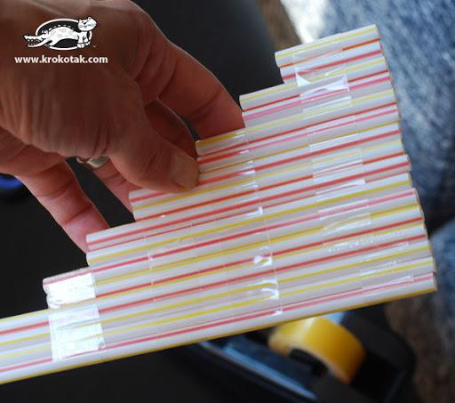Decorating/making their own instruments
  + Decorating maracas
  + Homemade harmonica
    - Materials:
      * Straws (**3 if standard length of 8.5 inches, 4 if shorter than that)**
      * Tape (any tape works)
      * Scissors (for cutting tape)
  + ***Below activities only if time remains***
    - Cup Xylophone
      * Materials:
        + 4-6 cups of the same size, shape, and material